**Buyers of pre-construction townhomes in Mississauga hit with 6-figure closing costs**

Home buyers with Haven Developments have been slapped with unexpected closing fees of up to $170,000 only two days before the closing deadline. Residents tell Mark McAllister they've been left to scramble for answers and more money.

**By Mark McAllister and Meredith Bond**

Posted Jul 20, 2022, 5:03PM EDT.

Last Updated Jul 21, 2022, 8:32AM EDT.

Several people who bought pre-construction townhomes nearly three years ago in Mississauga were forced to come up with between $70,000 and $170,000 in less than a week before they were able to close on their properties.

New owners at 1165 Journeyman Lane, also known as the Clarkson, were told by the property developer, Haven Developments, on Saturday that costs far exceeded what purchasers expected would be required in order to close on their purchases.

Documents sent to the buyers from the developers show everything from electrical meters to the water and sanitary costs in the tens of thousands of dollars.

“My notice told me that I had to come up with almost another 20 per cent down in order to secure my home,” said Michael Paluch, a first-time home buyer who was shocked to find out he had to come up with this money.

“Me and my fiancé put our life savings into this house, and the builder told us that our closing costs are going to be almost 20 per cent just to cover water and electric meters.”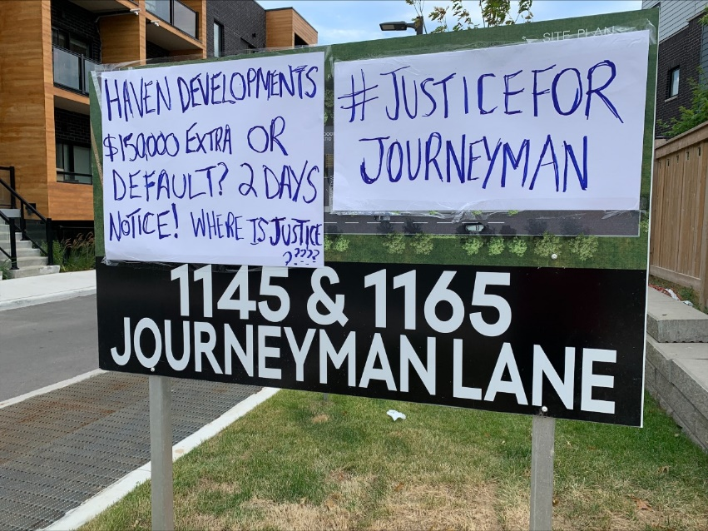*New owners at 1165 Journeyman Lane (2200 Bromsgrove Road developments) in Mississauga are given 2 days to find extra closing amounts anywhere ranging from $70,000 to over $170,000. Photo: Tony Fera/CityNews.*

Paluch tells CityNews they had to scramble to get loans from friends and family in order to cover the costs and keep their home. “Lawyers have told us that in their entire career, they haven’t seen costs this outrageous for closing.”

“We deal with the contracts in good faith, and to be hit with the fees that we’re getting 48 hours before closing … we feel it’s excessive,” said another buyer Chris. “I had to pay $125,000, had to come up with that money a day before closing and drop off a check.”

Chris said they were forced to take out a loan in order to cover the extra costs. “We don’t have that money lying around … We’re probably going to end up having to sell the place and move to kind of clear that. It’s very upsetting.”.

Nicole Pereira said she heard from her lawyer to expect to have $15,000 to $20,000 saved in order to close on the property. “I don’t think anyone was expecting upwards of six figures.”

“My own personal lawyers from the real estate transaction have been reaching out to their lawyers to try and get some answers. That has been really unsuccessful,” said Pereira.

“They’ve been really unresponsive to our requests about identifying where these charges are coming from, having some more explanation in terms of what exactly these charges are and why they are coming to us so late.”

Haven Developments tells CityNews there was “nothing exceptional about the current process despite the reaction of a handful of purchasers.”

“Adjustments to address final closing costs on the purchase of a new home in Ontario should not come as a surprise to any purchaser and, certainly not, to their legal counsel,” read a statement from Haven.

They explained the fees due at closing are not a source of profit for the developer, but they cover municipal development charges, parkland levies, the connection of utilities and related services, and additional infrastructure costs.

“In smaller new communities- with fewer purchasers- the shared burden of these closing costs may be higher than at larger communities with more homes,” it continued, adding the Clarkson development only contained 74 new homes.

“While we recognize the challenges closing costs can create for our purchasers, this eventuality is fully addressed in the Agreement of Purchase and a standard part of the new home buying experience in the province.”